Transition from Xpy-View to Xpy-Watch: Restoring current customer configuration
Manual 1.0

- Run the client software on your main screen and perform the steps listed below:
- Unlock the application, use the unlock pattern previously configured
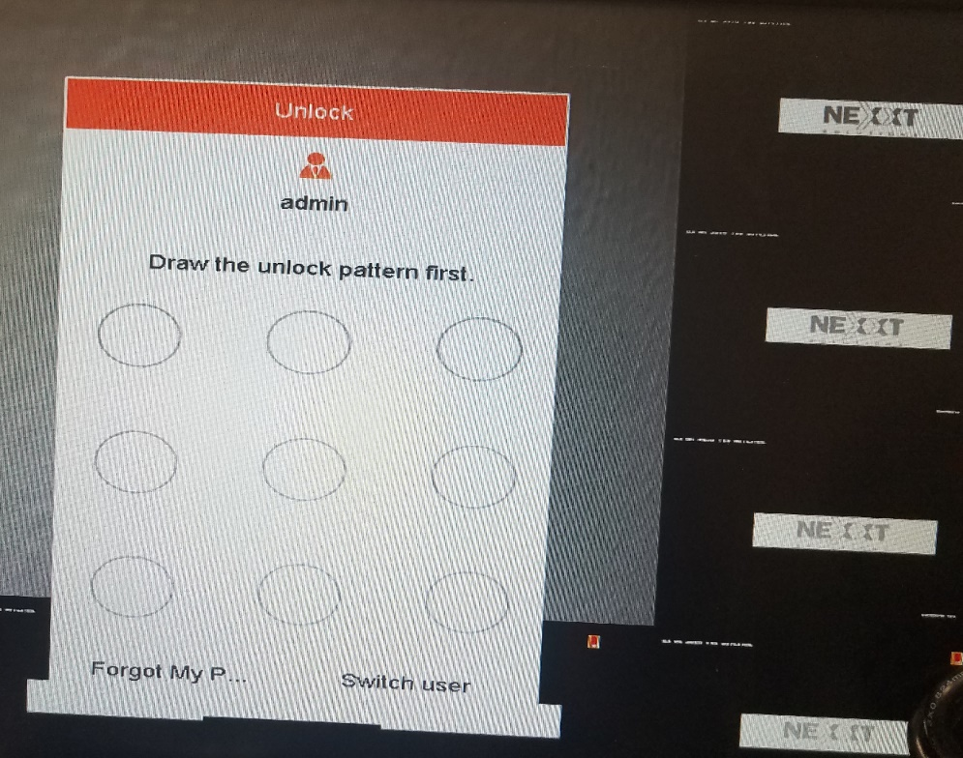
- Click on Menu
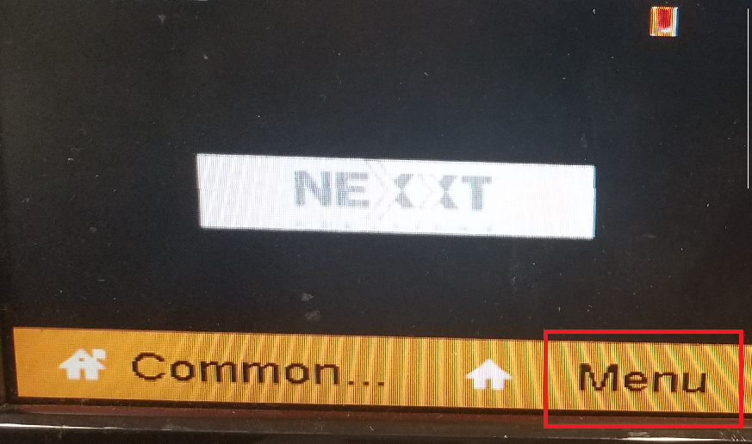
- Go to Configuration – Network
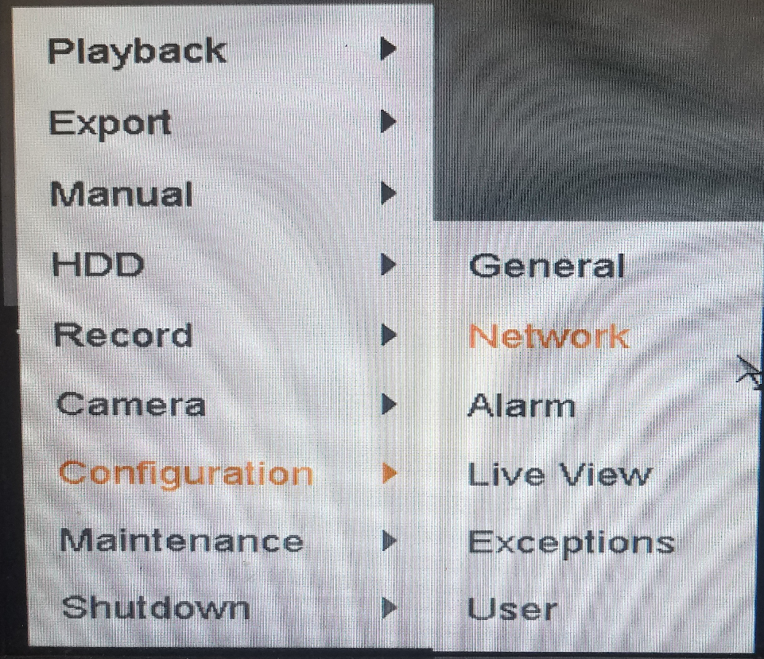
- Click on Platform Access
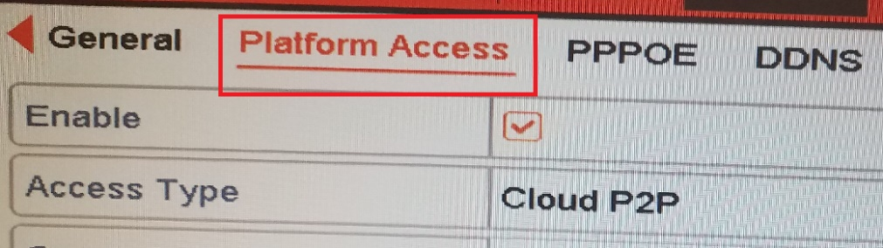
- Enable the checkbox marked as "Custom", once you make the selection it will light orange color
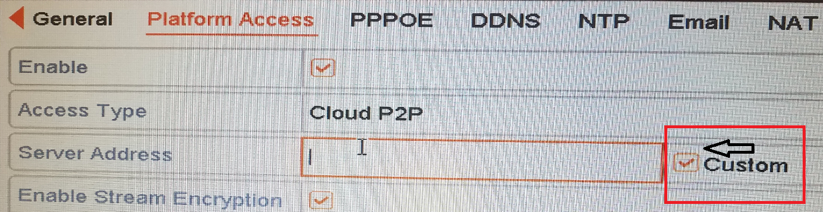
- Click on the text box marked as “Server Address”, delete the URL that registers by default and enter the new URL: dev.us.guardingvision.com , click on apply to save the changes
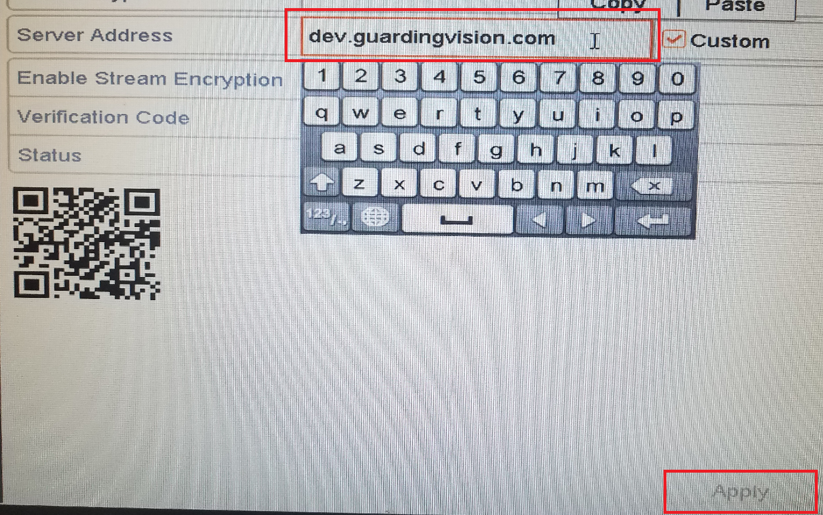
Note: Make sure that configuration wizard has taken the changes made, go to any part of the menu, then return to the configuration screen and confirm that the URL was changed
- Confirm the connection status of your system
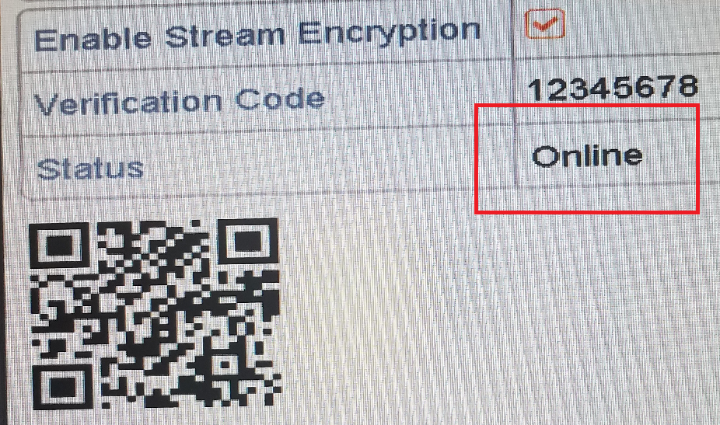

- Open XPY-View App, through your smartphone

- When the application shows the pop-up notification to update, click on cancel
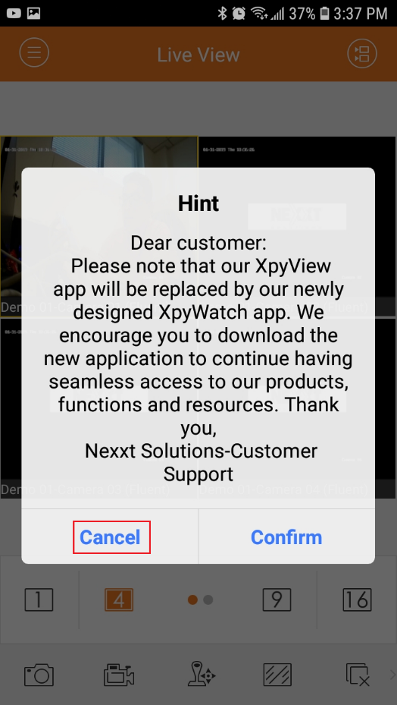
- Click On menu button, placed on the top
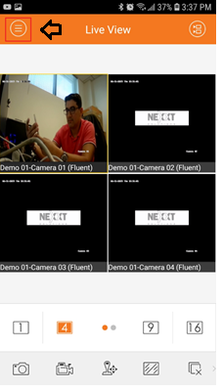
- On menu select Devices
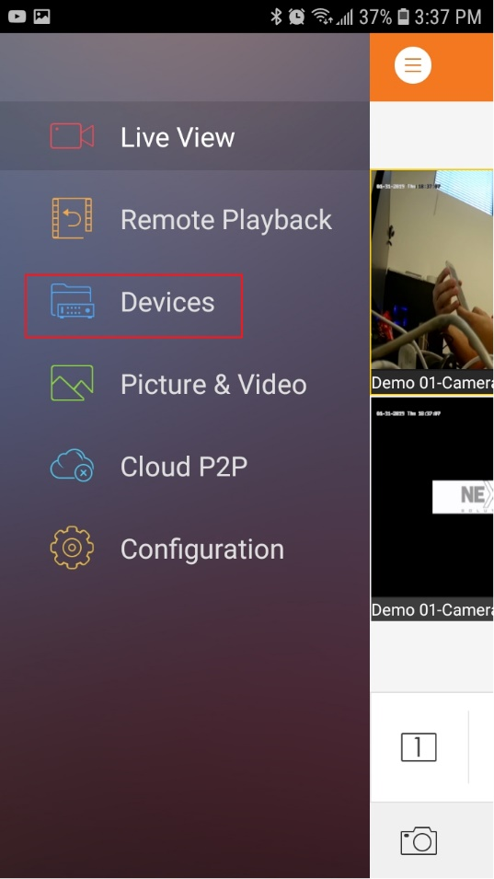
- Click on + Button
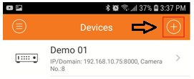
- Select Generate QR Code
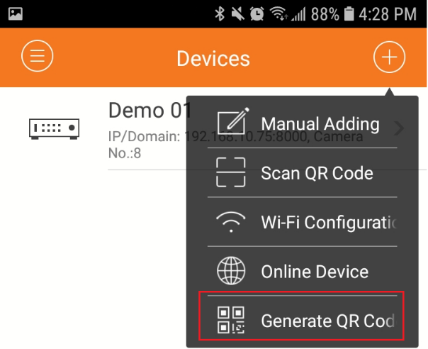
- Click on the checkbox marked with the device name, once selected the check color changes to orange
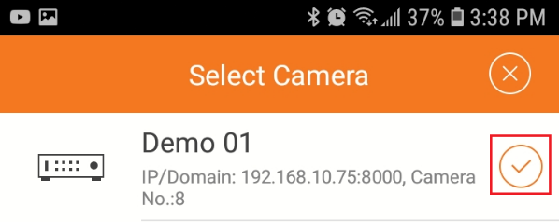
- Click on Generate QR code (1) button
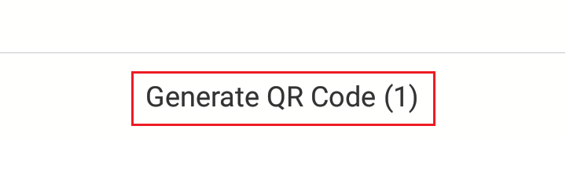
- Once the QR code is generated, take a screenshot of the QR code with your phone, the image will be automatically saved in the memory of your mobile device
Note: Review the smartphone guide to find the screenshot process on android or iOS

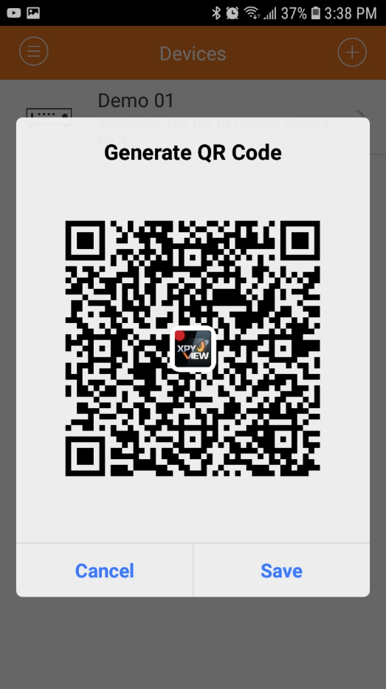

- Click on cancel to exit the image
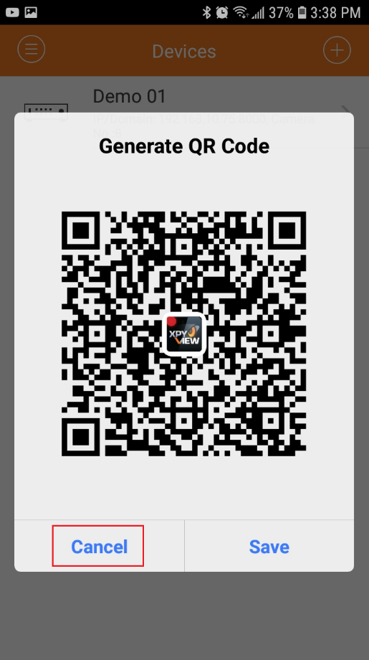
- Proceed to delete your previously linked device, to do so, press and hold on the device name until the delete option appears, click on confirm
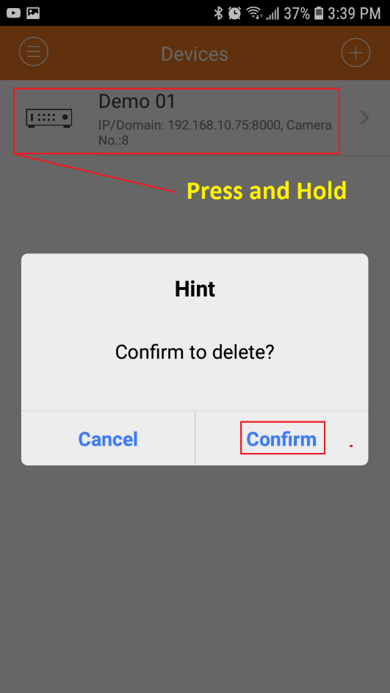
- Make sure that the list of devices is now empty
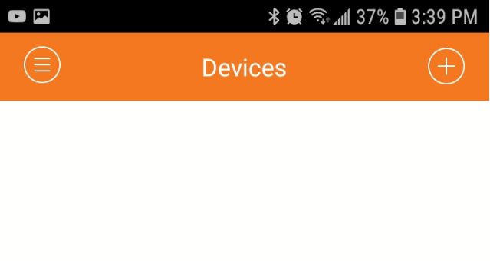
- Logout to the XPY-View application by clicking on the back-function button of your smart phone, click on confirm
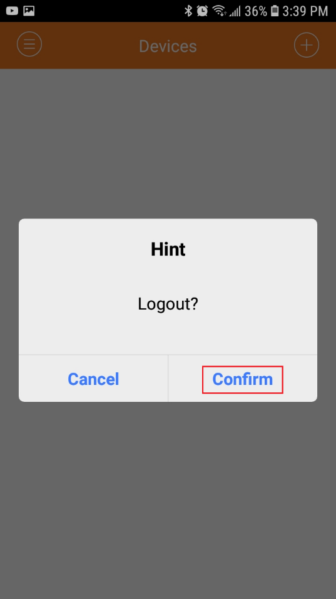
- Open the XPY-View app again, this time, click on confirm to download the new application XPY-Watch
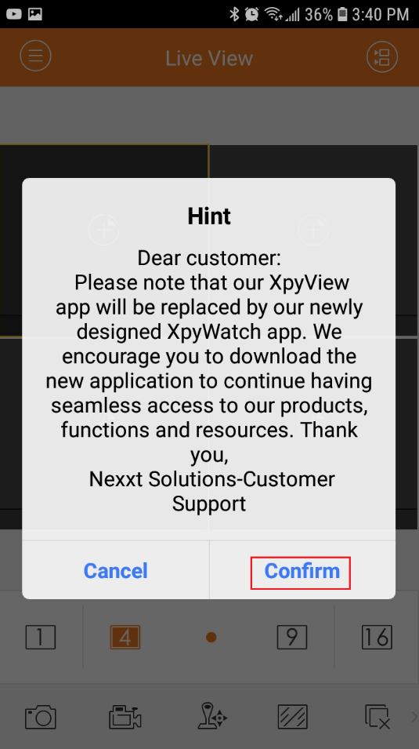
- This step will take you to the download manager for Android or iOS, click on Install

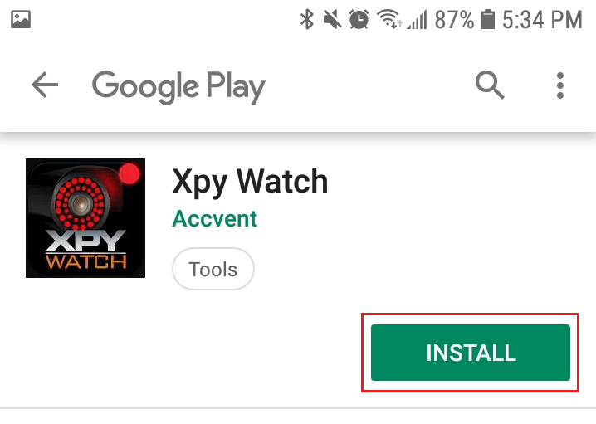

- Open XPY-watch App, through your smartphone
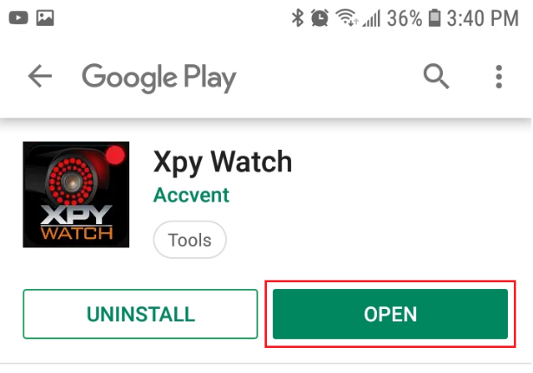
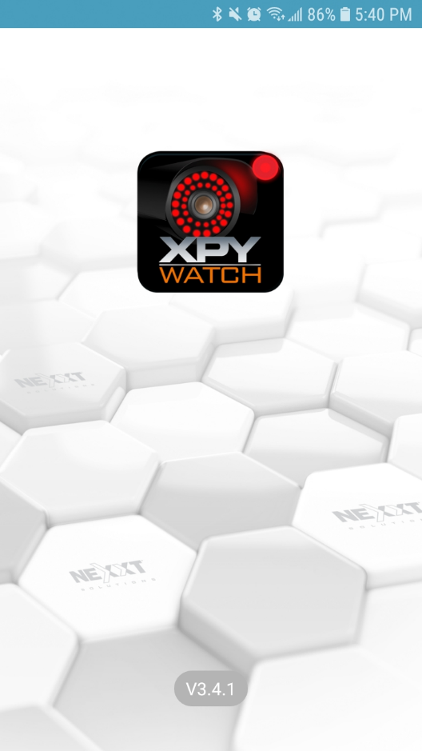
- Click on Select Country or Region and proceed to choose your location

- Select your location-for this illustration we will choose USA, click on the check box place on the top to continue
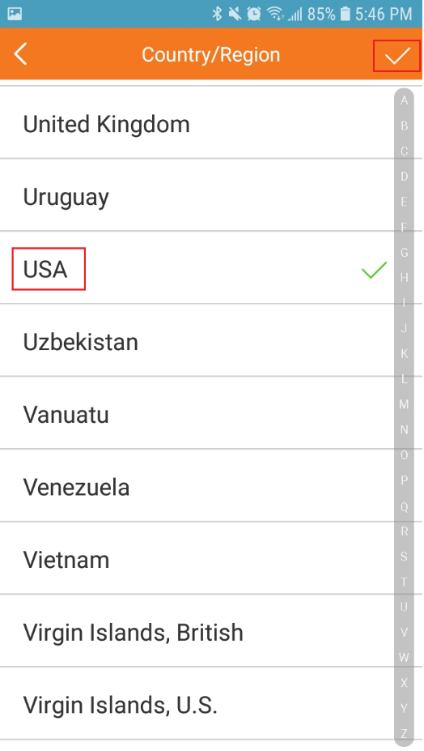
- Click on Login to access the account
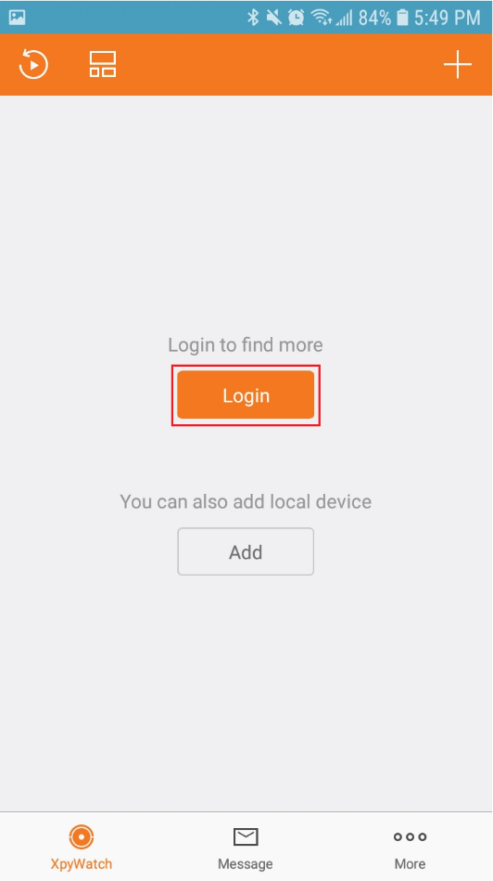
- Enter your username and password, click on Login
Note: If you do not have an account click on the Register button and follow the steps to create it. See manual 1.1
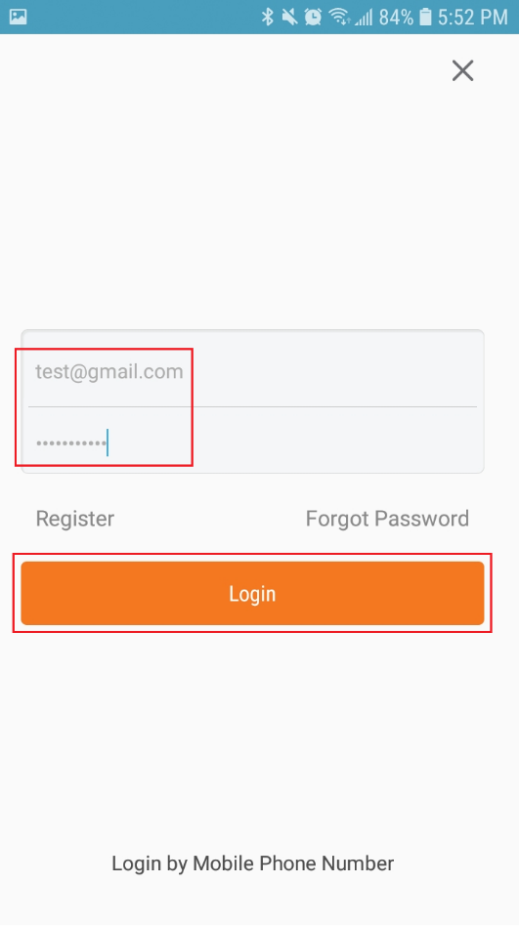
- Click on Add device
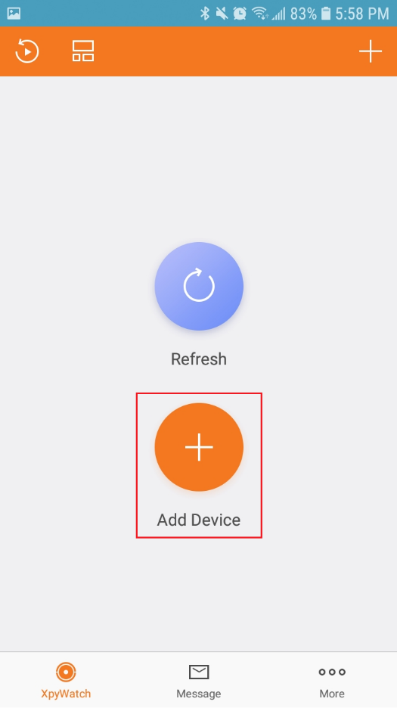
- The barcode scanner is now enabled, click on the gallery icon to search the image that we previously saved
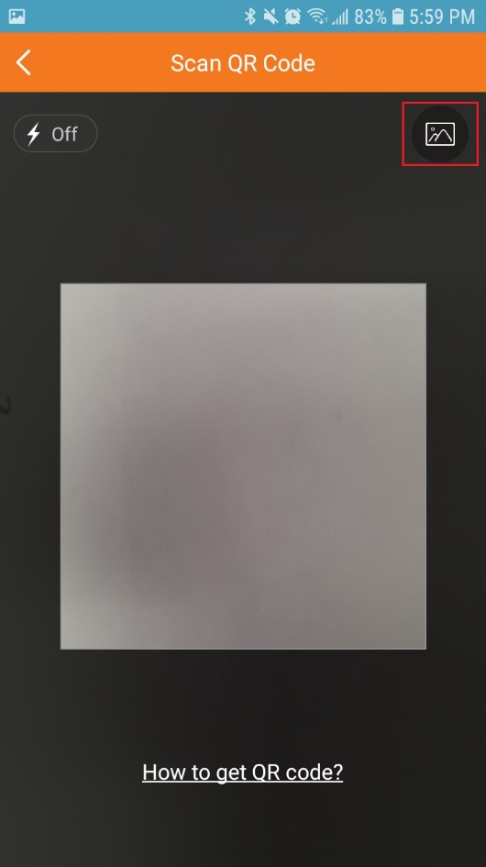
- Choose the image, once it is done, be sure to listen to the connection beep
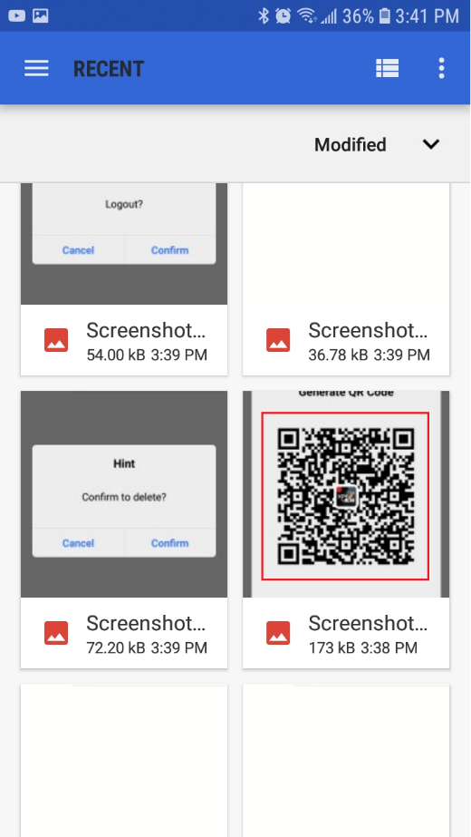
- Select the device that you want to link, once is done the check box changes to green, click on the Add (1) button
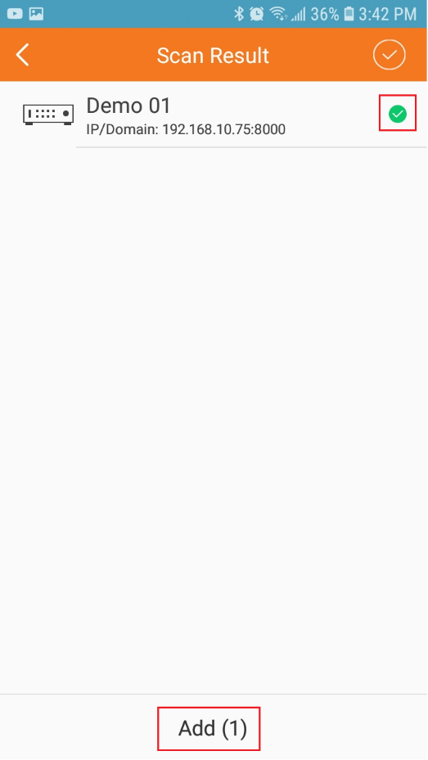
- Now the device is linked with its new Xpy-Watch app
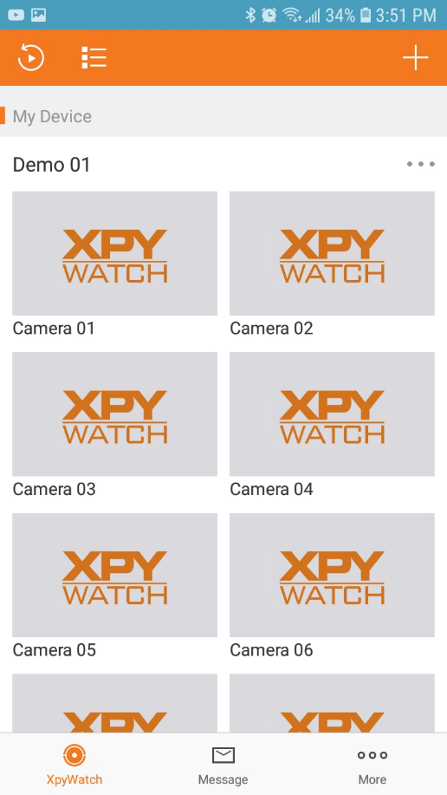

Manual 1.1
Register new account Xpy-Watch APP: New Customer

Client software installation for xpy watch is required for local administration.

Create XPY-Watch account, current/new customer
- Open XPY-Watch App, through your smartphone
- Click on Select Country or Region and proceed to choose your location
- Select your location-for this demonstration we will choose USA, click on the check box place on the top to continue

- Click on Login
- Click on Register to create the new account
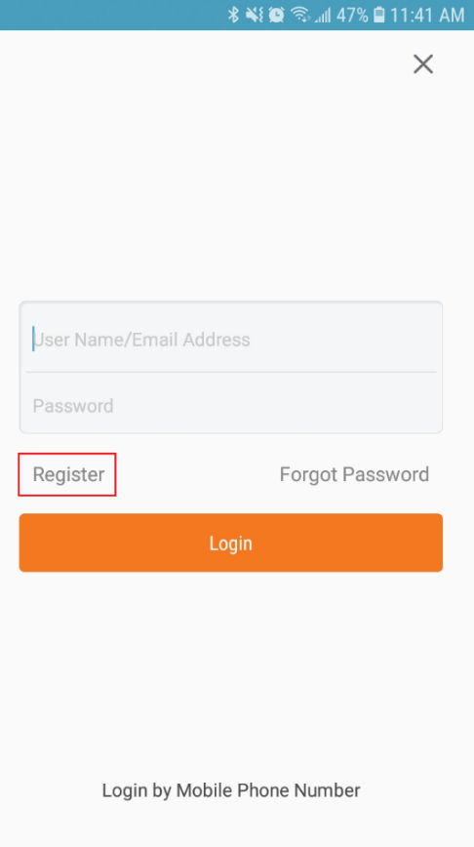
- Click on Register by Email address, accept the privacy policy
Note: You can choose between registration using your e-mail or your telephone number, for this example use e-mail
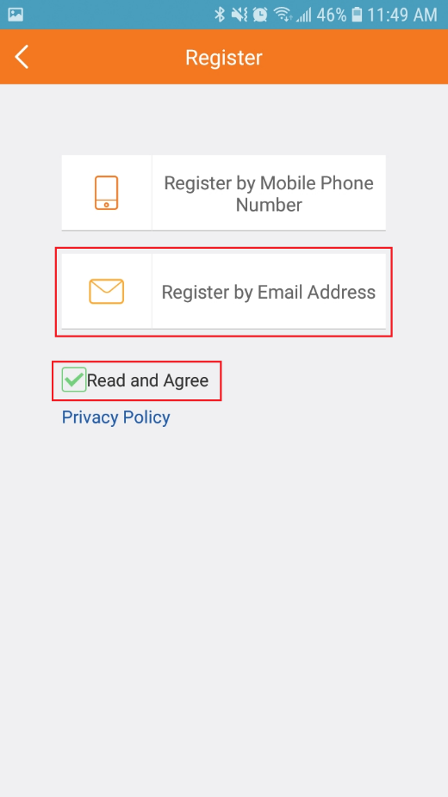
- Select your location again, click on finish button to continue
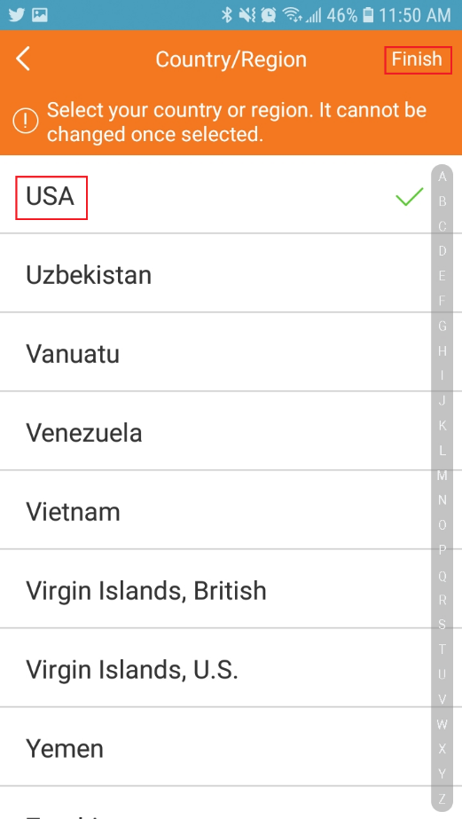
- Once the selection is made, you cannot change the location, make sure you enter your location correctly, click on OK
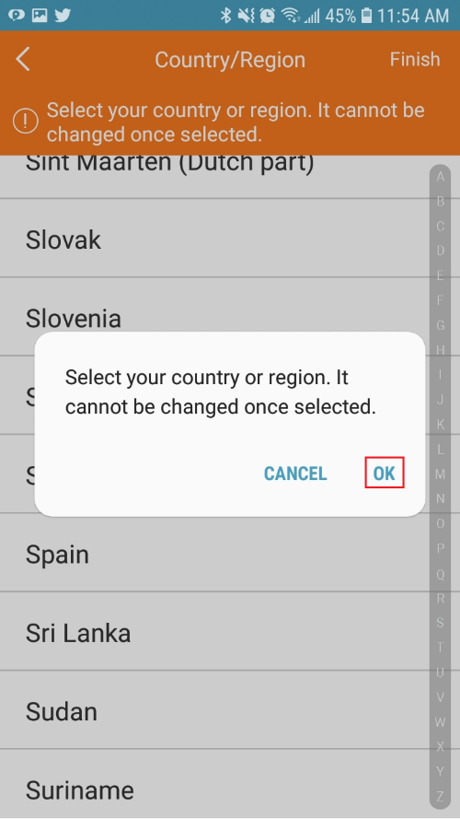
- Proceed to enter the email address that will be associated with this account, click on Next
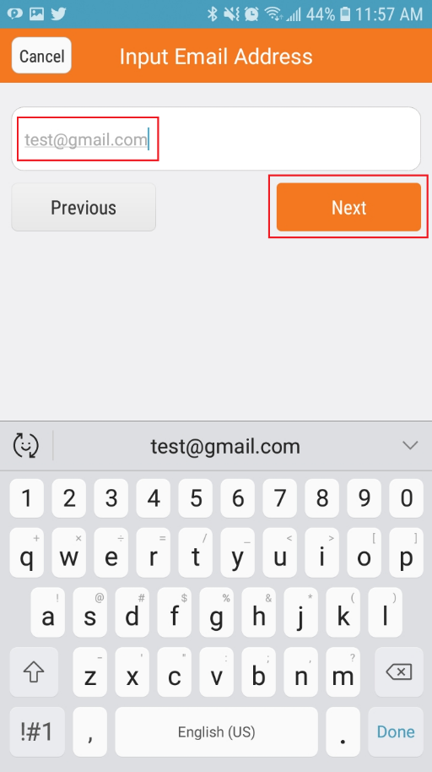
- Go to inbox of your mail application that you previously registered, there, you will find an email with a numeric verification code of 4 digits
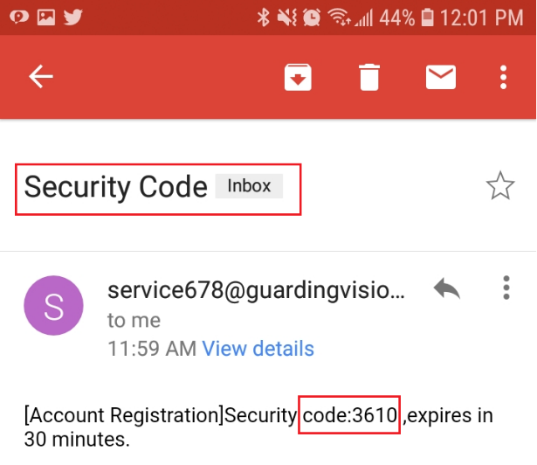
- Return to the configuration wizard and enter this code in the text box, click on next
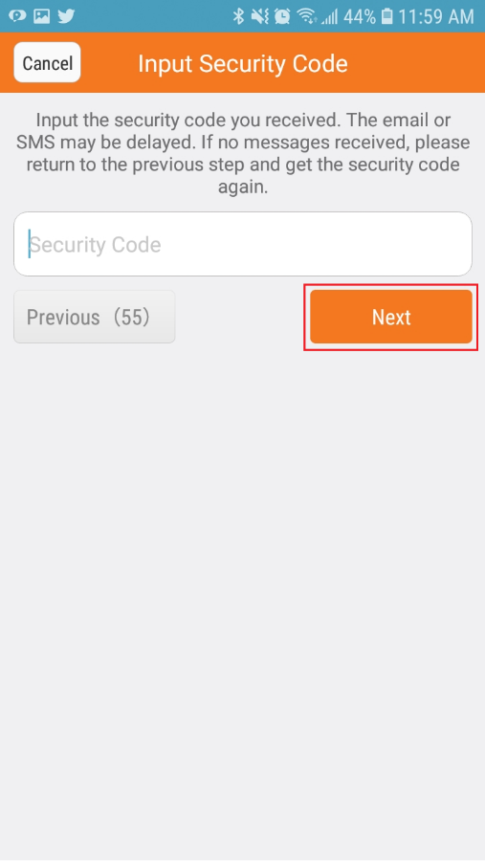
- Create a username, then create and confirm a new password to access your account, click on finish
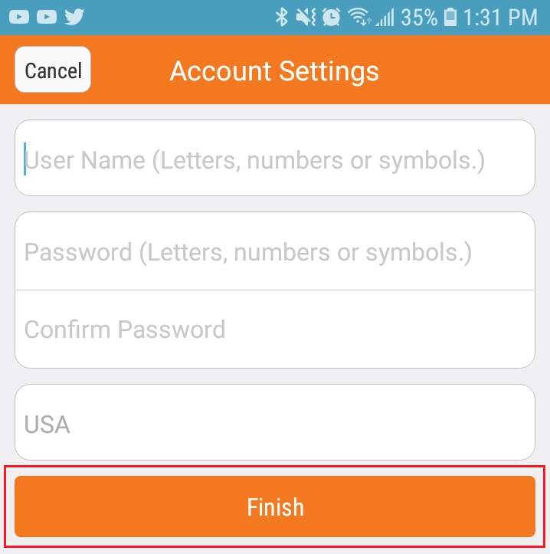
- The account is completely created

New customer add devices to Xpy-Watch
- Open XPY-watch App, through your smartphone
- Click on Select Country or Region and proceed to choose your location
- Select your location-for this illustration we will choose USA, click on the check box place on the top to continue
- Click on Login to access the account
- Enter your username and password, click on Login
- Click on Add device
- The barcode scanner is now enabled
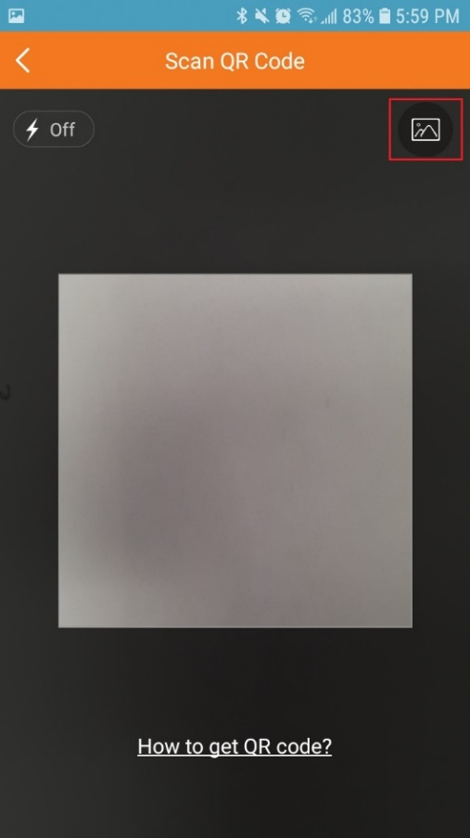
Note: You must obtain the QR code directly from the client software, the steps to obtain the QR code are detailed below:
- Unlock the application, use the unlock pattern previously configured
- Click on Menu
- Go to Configuration – Network
- Click on Platform Access, with your smart phone scan the QR code, make sure you hear the connection beep
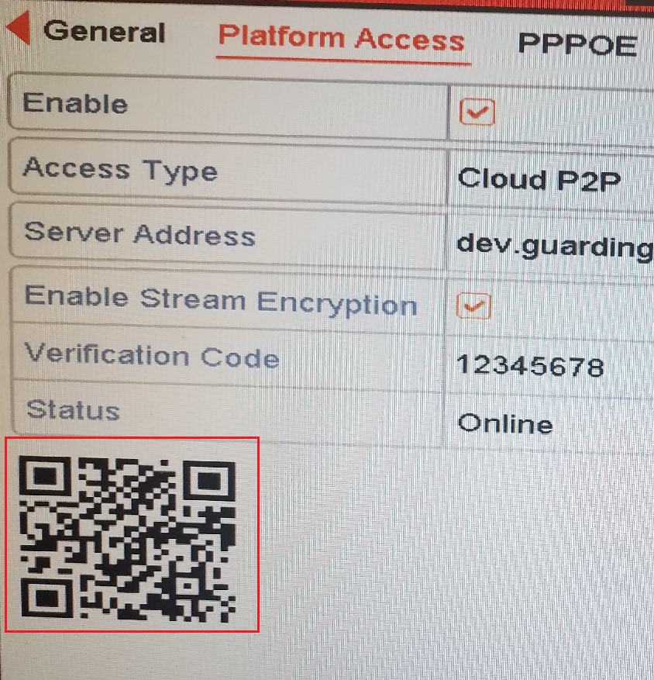
- Select the device that you want to link, once is done the check box changes to green, click on the Add (1) button
- Now the device is linked with its new Xpy-Watch app

